Received: | Revised: 25 | Accepted: DOI: 10.1111/jbi.14545

R E S E A RC H A R T I C L E

Biogeographical patterns for the conservation of Ecuadorian vipers (Squamata: Viperidae) under climate change scenarios.
Mateo Noboa¹

¹Grupo de Investigación en Biogeografía y Ecología Espacial, Facultad de Ciencias de la Vida, Universidad Regional Amazónica Ikiam, Tena, Ecuador
Abstract (300)

Aim(76): This research will provide knowledge on biogeographic patterns for the conservation of Ecuadorian vipers under future climate change scenarios by : (a) Identifying the natural regions of Ecuador where the major changes occur in the ecological niche of Ecuadorian vipers, in future climate change scenarios, (b) Estimating the degree of conservation (%) of the Ecuadorian vipers ecological niche in the National System of protected Areas. (c) Establish priority natural regions of Ecuador for the conservation of vipers, given the concentration of richness, endangered species, and endemism in climate change scenarios.

Location: Ecuador.
Taxon: Squamata: Viperidae
Methods(62): We obtained the data on Ecuadorian vipers species occurrence from online repositories and the national institute of biodiversity of Ecuador. The environmental data for the present a two future scenarios (RCP 4.5 and 8.5) was obtained from the WorldClim repository. The ENMs for present and future scenarios were generated using the R package KUENM. Those models were later contrasted with Ecuador’s natural regions and national protected areas system(SNAP) in order to assess the research purpose
Results(74):
1 We identified that the natural regions of Ecuador where the most changes occur in the ecological niche of Ecuadorian vipers on future climate change scenarios are Amazon , Eastern Foothill and Eastern Montane
2. The percentage of the ecological niche of Ecuadorian vipers within the SNAP is of 16.95%
3 The priory natural regions in Ecuador for vipers conservation based on the richness, threatened species, and endemism in future climate change scenarios are the lowlands natural regions of Ecuador

Conclusion(60): In conclusion, our study highlights the importance of the foothill and lowland natural regions in Ecuador for the conservation of vipers under current and future climate change scenarios . Additionally, targeted conservation measures should be extended beyond protected areas to safeguard the significant portion of vipers' ecological niche outside these areas

K E Y WO R D S(5) : Biogeographical patterns, Climate Change, Conservation Biogeography ,Ecuadorian Vipers, Ecological Niche modeling .

Correspondence
Mateo Noboa, ¹Grupo de Investigación en Biogeografía y Ecología Espacial, Facultad de Ciencias de la Vida, Universidad Regional Amazónica Ikiam, Tena, Ecuador
. Email: mateo.noboa@est.ikiam.edu.ec

Funding information

Handling Editor:

The two most important sources of global information on species distributions show dramatic differences in the estimation of global richness patterns of threatened vertebrates in marine islands.

Journal of Biogeography. 2022;00:1–10. wileyonlinelibrary.com/journal/jbi
© 2022 John Wiley & Sons Ltd. | 1

| INTRODUC TION(1000)

Anthropogenic climate change has been extensively documented, and it is predicted that without a significant reduction in greenhouse gas emissions, it could lead to an increase in global temperatures by over 4°C within this century(Huang et al., 2013). As ectothermic animals, vipers depend on external heat sources to carry out their physiological processes, and a rise in temperatures has been observed to increase their activity time, metabolic rate, digestive function, and activity levels, thus impacting their survival and reproduction(Carrillo et al., 2005). As temperatures rise, the habitats where vipers live are becoming drier and less hospitable(Ducatez & Shine, 2017) ,forcing vipers to move to new areas in search of suitable habitat, and some species are already struggling to adapt to the rapid environmental changes (Needleman et al., 2018).

Vipers play a crucial role in maintaining healthy ecosystems as they serve as predators that control the populations of prey species(Crews, 1988), thus contributing to the balance of the trophic chain. However, with possible changes in the distribution of venomous species, there is a risk that the incidence of snake bites could become a public health concern related to climate change (Yánez et al., 2021). The proteins isolated from snake venom have practical applications in pharmaceuticals, making it imperative to protect these invaluable natural resources (Kumar et al., 2002).

Moreover, studies have shown that Viperidae species and the ecosystems where they reside are vulnerable to the effects of climate change (Wu, 2016), which makes their conservation a top priority. Protecting these species and their habitats is crucial not only for their survival but also for the overall health of the ecosystem

Vipers, along with reptiles in general, are among the terrestrial vertebrates with the highest number of threatened species, exceeding the number of endangered bird or mammal species(Ducatez & Shine, 2017) . Unfortunately, they have been subject to indiscriminate depletion and population decline due to their historical perception as enigmatic and feared animals(Pandey et al., 2016).

The majority of viper species are found in the tropics and subtropics, where some are already experiencing temperatures above their optimal physiological range (Weiskopf et al., 2020). Ecuador is located in this region and is recognized as the seventh country in the world with the highest reptile diversity, including 401 species present in its territory with 17 belonging to the Viperidae family(Adhikari et al., 2018) .Among this vipers species one is endemic (Porthidium arcosae), twelve whose threat status by the IUCN red list standards (https://www.iucnredlist.org/) is of least concern(LC) : Lachesis acrochorda, Lachesis muta, Bothrops taeniatus, Bothrops asper, Bothrops pulchra, Bothrops punctatus, Bothrops brazili, Bothrops bilineatus, Bothrops atrox,Bothrocophias microphthalmus, Bothrocophias hyoprora, Bothriechis schlegelii, Porthidium nasutum, ; three whose level of threat is vulnerable (VU) : Bothrocophias campbelli , Bothrops lojanus, Bothrops osbornei ; And two with an endangered (EN) threat status : Porthidium arcosae (Carrillo et al., 2005), However, a national assessment of the threat level for most vipers in Ecuador has not been conducted, making the use of ecological niche models a practical tool for this purpose(Ortega et al., 2021)(Mcpherson et al., 2008).

The high diversity of species in Ecuador can be attributed to the country's location within the intertropical convergence zone and the presence of diverse altitudinal levels in the Andes(Esquerré et al., 2019). These conditions create a wide range of physical, climatic, and biological environments that contribute to the diversity of natural regions in Ecuador, each with unique characteristics and supporting a variety of endemic species (Hazzi et al., 2018).

. The rapidly changing Climate may alter the distribution of species and thus influence their biogeographic ranges(Guedes et al., 2018). If so These changes will affect ecosystem biodiversity ,thus their functions and services (Weiskopf et al., 2020). While the effects of climate change are far-reaching, they are not evenly distributed (Crews, 1988). This is particularly true for vipers, as many species have already shown sensitivity to changes in temperature and precipitation patterns(Wu, 2016).

Tropical and montane ecosystems are highly vulnerable to the impacts of climate change, according to research (Eguiguren et al., 2016)(Tovar et al., 2013) (Pepin et al., 2022). These ecosystems act as isolated islands that foster the development of endemic species, which are particularly vulnerable to climate change due to their limited ability to migrate and adapt (Herzog et al., 2012).

The actual or potential geographic distribution of a species can be characterized in terms of suitable environmental conditions modeled in an ecological space from its occurrence data, and then identify where these environments are distributed in a geographic space. For this type of model, two types of input data are required: 1) geo-referenced occurrence records of the species, and 2) a set of environmental variables. This process is formally known as Ecological niche modeling(ENM)(Soberón, 2010) The presence of a species in the geographical space can be explained by the interaction between the 3 factors in the BAM model proposed by soberon (Soberón & Peterson, 2008). However, there are several reasons why a species may not occupy environmentally suitable areas(A), such as geographic barriers (M)that limit dispersal in the area of biogeographic accessibility, or biological interactions (B)such as competition for resources(Pearson, 2010). Given that the geographical scale, in which we will be working, is broad the variables inside the B region of the BAM model can be explained by the variables found in the A region.(Barve et al., 2011)

Models that predict potential species distribution are a key tool for conservation biogeography, as they allow us to direct fundamental efforts in the conservation, planning, and management of biodiversity (Urbina & Flores, 2010) .

Biogeographical estimates of snake diversity would contribute to global and regional strategies for conservation. However, detailed data have not yet been compiled for the Neotropics, even though it comprises one of the richest herpetofauna in the world(Needleman et al., 2018)(Guedes et al., 2018)(Rautsaw et al., 2022). Vipers and other reptiles are more vulnerable to habitat loss, climate change, or other long-term changes, considering them as bioindicators of the processes that affect ecosystems(Shine & Bonnet, 2000) . This also makes them excellent models for assessing the potential effects of climate change on terrestrial ectotherms (Rautsaw et al., 2022).

Although a broad scientific consensus has been established on the presence of anthropogenic climate change, and its effects on wildlife, this is the first study to evaluate the effects of climate change on the distribution patterns of Ecuadorian vipers. This research will focus on providing knowledge on biogeographic patterns for the conservation of Ecuadorian vipers under future climate change scenarios. This objective will be accomplished by (a) Identifying the natural regions of Ecuador where the major changes occur in the areas of environmental suitability (ecological niche) of Ecuadorian vipers, in future climate change scenarios, (b) Estimating the degree of conservation (%) of the areas of environmental suitability of the Ecuadorian vipers in the National System of protected Areas (SNAP). (c) Establish the priority natural regions of Ecuador for the conservation of vipers, given the concentration of richness, endangered species, and endemism in climate change scenarios.

| MATERIAL S AND METHODS (1000)

2.1 Bioclimatic layers

The bioclimatic layers necessary for the modeling of areas of environmental suitability and their projections for future climate change scenarios will be obtained from the Worldclim2 database(Hijmans et al., 2005)(Fick & Hijmans, 2017) (http://www.worldclim.org). The 19 bioclimatic layers of the present and two future climate change scenarios (RCP 4.5 and RCP 8.5) will be downloaded in raster format with a spatial resolution of 30 arc seconds (~1 km2). We avoided using the four bioclimatic layers combining temperature and precipitation information (8,9,18,19), as these show unusual spatial abnormalities in the form of odd discontinuities between adjacent pixels (Escobar et al., 2014).The climate change scenarios are based on HadGEM2-ES data (a fully coupled atmosphere-ocean climate model) which interactively represents terrestrial and oceanic carbon cycles and dynamic vegetation with the option to prescribe atmospheric CO2 concentrations or to prescribe anthropogenic CO2 emissions and simulate CO2 concentrations(Jones et al., 2011). The RCP 8.5 model represents an extreme scenario in terms of greenhouse gas emissions, while the RCP 4.5 scenario assumes lower greenhouse gas emissions(Riahi et al., 2011) .

2.2 Database

Species records will be based on a systematic bibliographic review of viperids recorded in continental Ecuador for 17 species: Bothriechis schlegelii, Bothrocophias campbelli, Bothrocophias hyoprora, Bothrocophias lojanus, Bothrocophias microphthalmos, Bothrops asper, Bothrops atrox, Bothrops bilineatus, Bothrops brazili, Bothrops osbornei, Bothrops pulcher, Bothrops punctatus, Bothrops taeniatus, Lachesis acrochorda, Lachesis muta, Porthidium arcosae, Porthidium nasutum.(Ochoa et al., 2020) (Carrillo et al., 2005).

Records and georeferences will be obtained for the entire distribution range of the species, from the following open-access digital repositories: GBIF (https://www.gbif.org/), Vertnet (http://vertnet.org), Bioweb (https://bioweb.bio/), iNaturalist(https://www.inaturalist.org/), QCAZ(https://bioweb.puce.edu.ec/), FHGO(https://vivarium.org.ec/fhgo/),(http://www.biovirtual.unal.edu.co/es/colecciones/detail/364574/), and scientific collections from the national institute of biodiversity of Ecuador(https://bndb.sisbioecuador.bio/) We will then proceed to generate a taxonomically and geographically curated and validated database. To achieve this, we will (a) check for atypical records, (b) check for taxonomic names with possible errors (c) eliminate duplicate data and records without spatial data in order to avoid biased data.(Elith et al., 2011).

2.3 Delimitation of accessibility areas

The accessibility area ,M in the BAM model(Barve et al., 2011), refers to the geographic area that has been accessible to the species through dispersal during relevant periods(Soberón, 2010) . It will be delimited based on the geographic distribution of the validated records of each species in the biogeographic regions for the Neotropics(Morrone, 2014), as well as watersheds, and mountain ranges through a digital elevation model, as physical barriers(Mota et al., 2019)(Zurell et al., 2020).

2.4 Modeling of areas of environmental suitability and their projections in future projections in future climate change scenarios.

To model the areas of environmental suitability (ecological niche) and generate projections for each species, the protocol proposed by(Mota et al., 2019) will be followed. The selection of variables is based on: (a) extracting the values of the 19 bioclimatic layers associated with the record points of the viper species to be modeled, with the tool "extract multi values to points"; (b) a Jacknnife analysis to determine which are the most important variables for the model in the Maxent software; (c) a Pearson correlation analysis between the variables and the climatic data associated with the record points with the Past software (Hammer et al., 2001). The model is based on the records and the bioclimatic variables prioritized by Jackknife and not correlated (Elith et al., 2011).

Model validation is based on randomly selecting 20% of the records as test data to estimate omission rates over 5 replications, 5000 iterations, and with the threshold "10 percentile training presence" in order tu exclude the outlayers (Zurell et al., 2020). Finally, the best model was selected because of the low omission rates of the test points, AIC, and the values of the partial ROC statistic. The area under the partial ROC quantile is currently considered the standard method for assessing the accuracy of predictive distribution models (Townsend et al., 2008). It avoids the alleged subjectivity in the threshold selection process, when scores derived from the continuous probability are converted into a binary presence-absence variable(Lobo et al., 2008) .The modeling processes will be automated with a script in R studio (https://www.r-project.org/) by using the Kuenm package(Cobos et al., 2019) . Kuenm is an R package designed to help on the calibration , creation and evaluation of ENMs making collaborative use of the machine learning software for species distribution models maxent (Phillips et al., 2006).

The calibration of the models is done by creating a series of candidate models with the combination of the different parameters(regularization multiplier, combinations of feature classes, and distinct sets of environmental predictors) offered by maxent software . For each setting two models are created, one with the full data set and the other just with model training data.(Cobos et al., 2019). The best model is then chosen based on statistical significance, predictability and complexity , in that order of importance. First the models are filter by statistical importance based on partial ROC as it was established that is a more appropriate measurement than a full ROC(Jiménez-Valverde, 2012)(Lobo et al., 2008). The reaming models predictability is then evaluated by their omission rate(10%<) of the testing data , in order to measures the model performance (Anderson et al., 2003). Finally, the best final model is chosen based on their complexity based on AICc values (2<)a measure that explain how well the model fits the data at the same time it favors simpler models (Warren, 2011).

2.5 Priority natural regions of Ecuador for the conservation of Viperidae in climate change scenarios given their richness, endemism and threat status.

Climate contraction is defined as the reduction of the areas of environmental suitability (A) within the area of accessibility (M) in a defined period of time for the species(Scheele et al., 2017), while expansion is the increase of environmentally suitable areas for the species within its geographic area of accessibility for a given time period(Sjödin et al., 2018)(Pulliam, 1986).

In order to determine the natural areas of Ecuador with the greatest change in the areas of environmental suitability for viper species in scenarios of future climate change, future projections will be contrasted with current models. In the analysis, the areas of ecological contraction and expansion of the niches and their changes for each natural region will be determined.

The models of richness, endemic and threatened species will be compiled in maps that represent species accumulation, through the summation of raster layers with the map algebra of ARCMap 10.5 (www.esri.com/es-es/arcgis/products/arcgis-desktop/) To determine the priority natural regions for conservation, first the 17 models of environmental suitability will be summed to determine where there is greater richness, endemism and threatened species. Subsequently, the same procedure will be carried out with the future projections and will be contrasted with the shape file of natural regions to determine which is the highest priority for conservation.

2.6 Degree of conservation of environmental suitability areas of Viperidae in the SNAP

To determine the degree of conservation of the areas of environmental suitability of Viperidae species in the SNAP, we will proceed to spatially estimate the percentage (%) of the model area included in the protected areas, given that the resolution of 30 arc-seconds represents approximately pixels of one km2.

- | RESULTS(650)

3.1 Current And future distribution of the ecological suitable areas of Ecuadorian vipers

In the present study, we investigated the distribution of the ecological niche of Viperidae species in continental Ecuador under current climate conditions. Our analysis revealed that the ecological niche of these species is widely distributed across almost all tropical areas, spanning from the southern part of Mexico to the middle of the southeastern part of Brazil. With the exception of areas with higher altitudes and associated colder and drier ecosystems, almost all of Ecuador is part of the ecological niche of vipers. Moreover, our findings indicate that the Lower Amazon region, located to the east of Ecuador, exhibits the highest species richness of vipers. In contrast, the western coastal lowlands are characterized by the lowest species richness .Figure 1

Regarding the two future climate change scenarios, RCP 4.5 and 8.5 see Figure 2 and Figure 3, similar patterns in the distribution of the ecological niche of vipers are expected. Both scenarios predict a significant ecological contraction, with almost total loss of the ecological niche in the western lowlands of Ecuador, while the eastern part is expected to be less affected. This effect being more notable in It is worth noting that some species' ecological niches may expand to higher altitudes, suggesting that they may adapt to new climatic conditions. These predictions highlight the importance of understanding and monitoring the impacts of climate change on viperidae species and their ecological niches in order to develop appropriate conservation strategies for these important species. This can also be appreciated in Figure 5
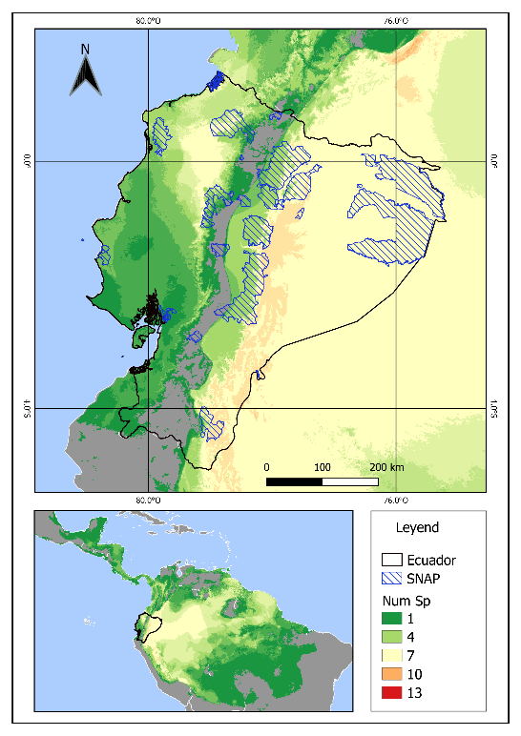
FI G U R E 1. The Ecological Niche Accumulation of the 17 Viperidae Species in the Present Time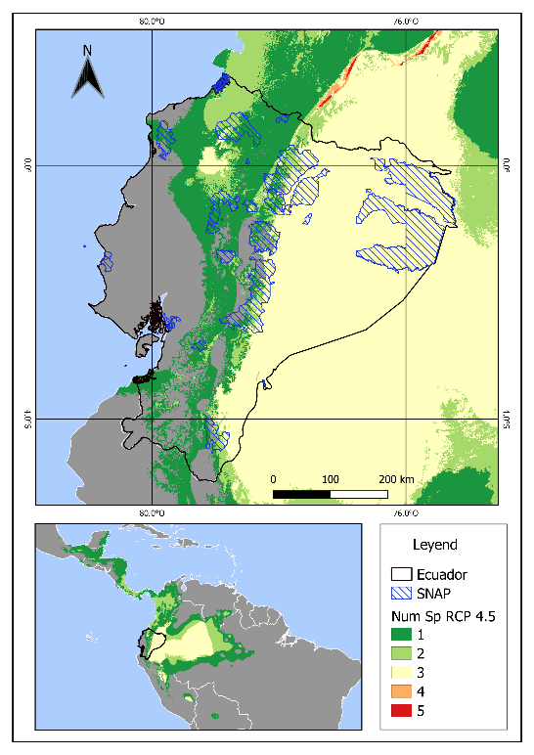
FI G U R E 2 The Ecological Niche Accumulation of the 17 Viperidae Species Modeled in climate change scenario RCP 4.5

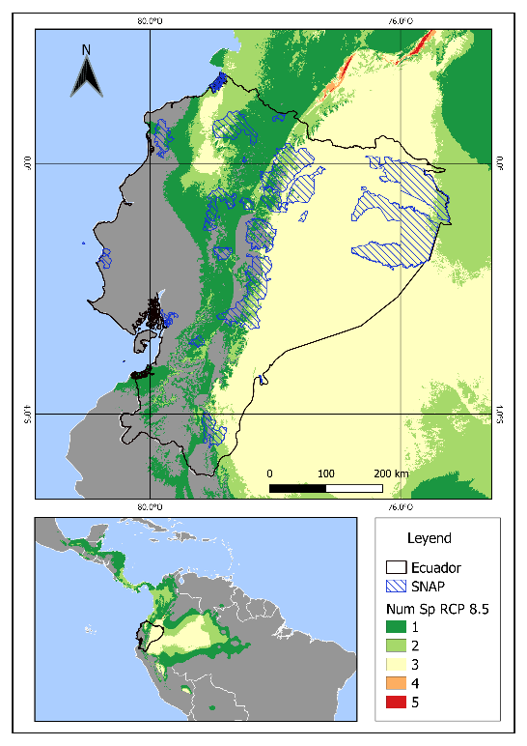

FI G U R E 3 The Ecological Niche Accumulation of the 17 Viperidae Species Modeled in climate change scenario RCP 8.5

3.2. Natural regions of Ecuador where the major changes occur in the areas of environmental suitability (ecological niche) of Ecuadorian vipers, in future climate change scenarios

In both RCP 4.5 and 8.5 climate change scenarios, there is a clear pattern of niche contractions occurring mostly in the lowlands, particularly in the eastern part of Ecuador. This pattern is likely due to the higher species richness in this area. Conversely, climate niche expansions are notably tending towards higher areas in both scenarios, indicating that many lowland species are migrating to colder and higher regions to meet their physiological temperature needs. (Figure 4)

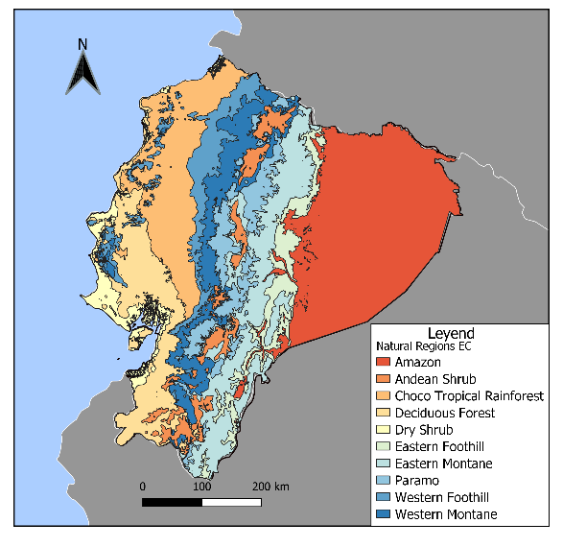
FI G U R E 4 Natural Regions of Ecuador

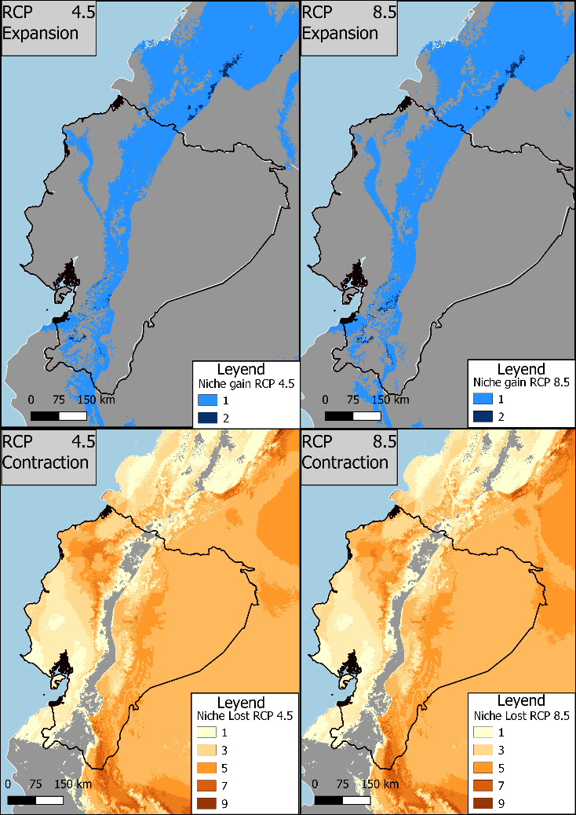

FI G U R E 5 Ecological expansion and contraction in climate change scenarios RCP 4.5 AND RCP 8.5

In the RCP 4.5 scenario, the Amazon (A), Eastern Foothill (E.F), and Eastern Montane (E.M) regions experienced the most significant changes. The Amazon region lost the niche of five viper species, while the Eastern Foothill region lost the niche of seven species, with no compensation through niche expansion. The Eastern Montane region experienced a contraction in the niche of eight species but also gained the niche of two species through expansion , leaving it with a total of 6 species in its area(Figure 6 and Figure 7). In the RCP 8.5 scenario, the regions with the most significant changes remain the same as in RCP 4.5, namely the Amazon (A), Eastern Foothill (E.F), and Eastern Montane (E.M) regions. However, in this scenario, there is one difference as the Amazon region gains one viperidae species by niche expansion in its area(Figure 8 and Figure 9).

FI G U R E 6 Ecological niche expansión per Natural región in Climate change scneario RCP 4.5

FI G U R E 7 Ecological niche contraction per Natural región in Climate change scneario RCP 4.5

FI G U R E 8 Ecological niche expansión per Natural región in Climate change scneario RCP 8.5

FI G U R E 9 Ecological niche contraction per Natural región in Climate change scneario RCP 8.5

3.3. the degree of conservation (%) of the areas of environmental suitability of the Ecuadorian vipers in the National System of protected Areas (SNAP)

The area corresponding to the sum of the ecological niche models for the 17 viper species recorded in continental Ecuador is equivalent to 266,126 km2, of which 45,117 km2 are contained within the Sistema Nacional de Áreas Protegidas (National System of Protected Areas, SNAP). This means that the SNAP contains 16.95% of the ecological niche of Ecuadorian vipers.

These results highlight the need to increase conservation efforts in areas outside of protected areas, as they represent a significant portion of the ecological niche of vipers. However, there is some encouraging news. The SNAP covers a total area of 46,799 km2, and 96.41% of it contributes to protecting the ecological niche of vipers, leaving only 3.59% of the ecological niche unprotected.

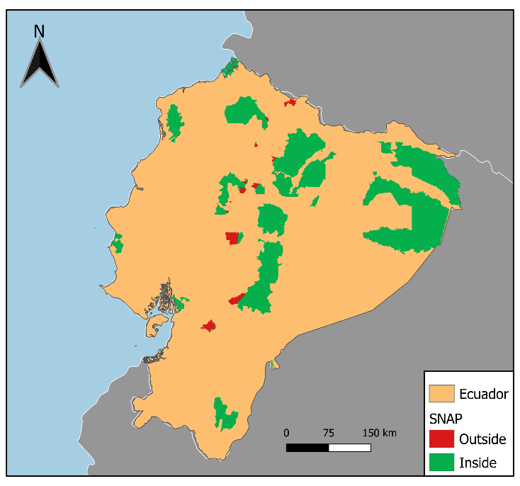
FIGURE 10 Viperidae ecological niche within SNAP

FI G U R E 11 Cumulative richness of species per Protected area

3.4. priority natural regions of Ecuador for the conservation of vipers, given the concentration of richness, endangered species, and endemism in climate change scenarios

3.4.1 Current Climate scenario

In the current climate scenario, the priority natural region in Ecuador for the conservation of vipers, based on cumulative richness, is the Eastern Montane (E.M) region. This region contains the highest number of species within its area, with a total of nine, followed closely by three other natural regions that each contain eight species: Amazon (A), Andean Shrub (A.S), and Eastern Foothill (E.F). It is not surprising that the natural regions with the lowest species richness, with a total of five species, are the Dry Forest (D.F) and Paramo (P) regions. Given that Not many ectothermic animals can adapt to the low temperatures and dry weather that characterize these regions .For more information see figure 11

FI G U R E 12 Cumulative species Richness in Ecuador’s natural regions in current climate scenario. (the abbreviations for the different natural regions of Ecuador are as follows: A for Amazon, A.S for Andean shrub, C.T.R for Choco Andean forest, D.F for deciduous forest, DS for Dry shrub, E.F for eastern foothill, E.M for eastern Montane, P for paramo, W.F for Western Foothill, and W.M for western montane.)

TA B L E 1. Ecological niche area (Km2) per natural region in current climate scenario

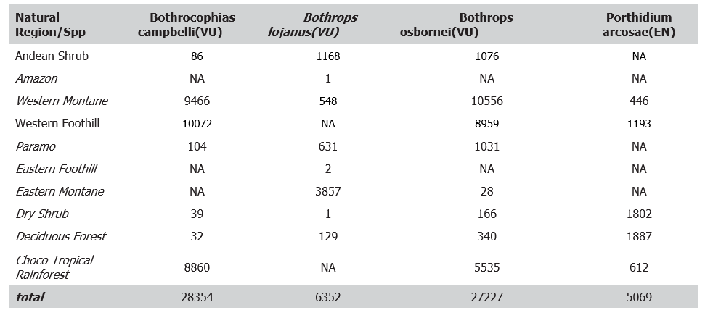

According to our analysis of endemism, the top priority natural region for conservation in Ecuador is the deciduous forest. This region contains a significant portion (37.23%) of the ecological niche of the endemic species Porthidium arcoase, covering an area of 1887 km². The Dry shrub region is a close second, covering 35.55% of its niche .

Based on the distribution of threatened species, According to our analysis, the Western Foothill region (33.39% of niche) is the priority natural region for conserving the Botrhocophias campbelli (VU) species. For the Bothrops osbornei (VU), the Western Montane region (37.23% of niche) is the most important region. The Bothrops Lojanus (VU) species is best conserved in the Eastern Montane region, while the deciduous forest region (37.23% of niche) is the top priority for conserving the Porthidium Arcoase (EN) species.
3.4.2 RCP 4.5 Cilmate change scneario

In the RCP 4.5 climate change scenario, eight natural regions have an equal conservation priority based on their species richness as they host three species each. These regions are Amazon (A), Andean Shrub (A.S), Choco Andean Forest (C.T.R), Eastern Foothill (E.F), Eastern Montane (E.M), Paramo (P), Western Foothill (W.F), and Western Montane (W.M). However, the Dry Forest (D.F) and Dry Shrub (D.S) regions have the lowest species richness, with only two species each.. See Figure 13

FI G U R E 13 Cumulative species richness per natural región in climate change scenario RCP 4.5

TA B L E 2. Ecological niche area (Km2) per natural region in RCP 4.5 climate scenario

Natural Region/Spp | Bothrops lojanus(VU) | Bothrops osbornei(VU)
Andean Shrub | 301 | 76
Amazon | NA | NA
Western Montane | 75 | 2316
Western Foothill | NA | 4138
Paramo | 134 | 3
Eastern Foothill | 16 | NA
Eastern Montane | 377 | NA
Dry Shrub | 817 | 21
Deciduous Forest | 1273 | 503
Choco Tropical Rainforest | NA | 427
total | 2975 | 7465

In the RCP 4.5 climate change scenario, there is no priority natural region for conservation due to the disappearance of the ecological niche of the endemic species Porthidium Arcoase in Ecuador

The priority natural regions for conservation based on threatened species in the RCP 4.5 climate change scenario are the Western Foothill region for Bothrops osbornei (VU), which covers 31.02% (2316 Km2) of its niche, and the Deciduous Forest region for Bothrops lojanus, covering 42.79% (1273Km2) of its niche. However, for the other two species, there is no priority region for conservation as their ecological niche disappears.

3.4.3 scenario RCP8.5

In the context of climate change scenario RCP 8.5, the natural region with the highest priority for viper conservation is the eastern montane (E.M). This region exhibits the highest species richness, with a total of four species. On the other hand, the dry forest (D.F) region contains the lowest species richness, with only two species in its area. The remaining natural regions all contain three viper species niches. Therefore, conservation efforts should focus on protecting the eastern montane region as a high priority.

FI G U R E 10 Cumulative species richnes per natural región in climate change scneario RCP 8.5

TA B L E 3 . Ecological niche area (Km2) per natural region in RCP 4.5 climate scenario

Natural Region/Spp | Bothrops lojanus(VU) | Bothrops osbornei(VU)
Andean Shrub | 564 | 104
Amazon | NA | NA
Western Montane | 244 | 2262
Western Foothill | NA | 5674
Paramo | 283 | 4
Eastern Foothill | 147 | NA
Eastern Montane | 762 | 1
Dry Shrub | 867 | 140
Deciduous Forest | 1498 | 724
Choco Tropical Rainforest | NA | 4894
total | 4261 | 13722

As in the previous case In the RCP 8.5 climate change scenario, there is no priority natural region for conservation due to the disappearance of the ecological niche of the endemic species Porthidium Arcoase in Ecuador

Based on the threatened species in the RCP 8.5 climate change scenario, the Western Foothill region is a priority natural area for conservation of Bothrops osbornei (VU), covering 41.35% (5674 Km2) of its niche, followed by the Deciduous Forest region for Bothrops lojanus, covering 35.16% (1498 Km2) of its niche. However, for the remaining two species, there is no priority region for conservation as their ecological niche is projected to disappear.

| DISCUSSION (1500)

The distribution and richness of viper species across the different natural regions in Ecuador is a key factor to consider in the development of conservation strategies for these important reptiles, particularly in the face of climate change because poses serious threats to the conservation of natural landscapes worldwide and is considered to be one of the main drivers of the current biodiversity crisis (Weiskopf et al., 2020)

Natural Regions

The different natural regions in Ecuador that host viper populations are characterized by unique environmental conditions that influence the diversity and distribution of these species. The Eastern Montane region, which includes the high-altitude forests of the Andes Mountains, has a high species richness of vipers due to the diverse habitats it provides, including cloud forests, montane forests, and high-elevation grasslands(Pepin et al., 2022). Making this region an important area for biodiversity conservation.

The Amazon region, on the other hand, is characterized by the humid and tropical rainforest ecosystems that support a diverse range of flora and fauna, including several species of vipers. The Andean Shrub region, located in the inter-Andean valleys, has a semi-arid climate and supports a variety of vegetation types such as dry forests, scrublands, and cactus groves(Hazzi et al., 2018)., which provide habitat for eight species of vipers.

The Paramo region, located in the high-elevation grasslands of the Andes Mountains, is characterized by harsh environmental conditions, including low temperatures and strong winds(Tovar et al., 2013), which limit the diversity of species that can survive in this region.

Current Climate Scenario:

Our study has identified the Eastern Montane region as a priority area for the conservation of vipers in the current climate scenario, due to its high species richness with nine species recorded within its area. This region is closely followed by three other natural regions, each containing eight viper species, including the Amazon, Andean Shrub, and Eastern Foothill regions. In contrast, the Dry Forest and Paramo regions exhibit the lowest species richness with a total of only five species.

Based on endemism, the deciduous forest is the top priority natural region for conservation in Ecuador. It contains a significant portion of the ecological niche of the endemic species Porthidium arcoase(EN).

In terms of threatened species, the Western Foothill region is the priority natural region for conserving the Botrhocophias campbelli (VU) species, while the Western Montane region is the most important region for the Bothrops osbornei (VU) species. The Eastern Montane region is the best place to conserve the Bothrops Lojanus (VU) species. Finally, the deciduous forest region is the top priority for conserving the Porthidium Arcoase (EN) species, given the significant portion of its ecological niche that is found in this area.

Future Climate Change Scenario RCP 4.5:

Under the future climate change scenario RCP 4.5, our study revealed that eight out of the ten natural regions contain three viper species within their area, highlighting the importance of conserving these regions to maintain viper populations in Ecuador. The Eastern Montane, Western Montane, and Choco Andean Forest regions, which are located in the Andes Mountains, are among the priority areas for viper conservation under this scenario. On the other hand, the Dry Forest and Dry Shrub regions have the lowest species richness, with only two viper species found in their area.

The disappearance of the ecological niche of the endemic species Porthidium Arcoase and Bothrops cambelli in Ecuador in the RCP 4.5 climate change scenario is a concerning finding, indicating the potential loss of unique and valuable biodiversity. It is important to note that the disappearance of a species' ecological niche can have cascading effects on entire ecosystems, including the loss of important ecosystem services, such pest control.

The identification of priority natural regions for conservation based on threatened species in the RCP 4.5 climate change scenario provides valuable information for conservation planning. The Western Foothill region and Deciduous Forest region are highlighted as important areas for conservation of Bothrops osbornei and Bothrops lojanus

Future Climate Change Scenario RCP 8.5:

In the more severe climate change scenario RCP 8.5, the Eastern Montane region remains the priority area for viper conservation, with a total of four species recorded within its area. The Dry Forest region has the lowest species richness, with only two species present, while the remaining natural regions contain three viper species each. These findings suggest that conservation efforts should prioritize the Eastern Montane region, particularly under the more severe climate change scenario, to protect the high species richness of vipers present in this region.

The disappearance of the ecological niche of the endemic species Porthidium Arcoase in both RCP 4.5 and RCP 8.5 scenarios highlights the urgency and importance of conservation efforts to prevent further loss of biodiversity due to climate change. The lack of a priority natural region for conservation in both scenarios for this species emphasizes the need for comprehensive and coordinated conservation strategies that focus on protecting and restoring habitats across Ecuador.

On a positive note, the identification of priority natural regions for conservation of threatened viper species in both scenarios provides valuable insights for conservation efforts. The Western Foothill and Deciduous Forest regions are identified as priority natural areas for the conservation of Bothrops osbornei and Bothrops lojanus, respectively, in both scenarios. These results can help guide conservation management plans and prioritize conservation efforts in these regions.

Conservation Strategies:

Our results also highlight the importance of protecting areas outside of the Sistema Nacional de Áreas Protegidas, as a significant portion of the ecological niche of vipers in Ecuador occurs outside of these protected areas. However, it is encouraging to note that the SNAP covers a large area and protects the majority of the ecological niche of vipers in Ecuador, leaving only a small percentage of the niche unprotected. These findings emphasize the need for targeted conservation efforts in areas outside of protected areas specially in those where the most changes are expected in future climate change scenario(A,E.M,E.F), while also recognizing the important role that protected areas play in preserving the ecological niche of vipers in Ecuador.

By studying the responses of vipers to changes in temperature and other environmental factors, researchers could gain insights into the potential effects of climate change on other ectothermic species, as well as inform the development of management and conservation strategies for these organisms(Shine & Bonnet, 2000).

Moreover, vipers are found in a wide range of habitats, including high-elevation forests, lowland rainforests, dry forests, and shrublands, making them an excellent model species for studying the impacts of climate change across different natural regions. Additionally, their relatively long lifespan and slow reproductive rates make them particularly vulnerable to changes in the environment, highlighting the importance of studying their responses to climate change(Carrillo et al., 2005).

In conclusion, our study highlights the importance of the foothill and lowland natural regions in Ecuador for the conservation of vipers under current and future climate change scenarios based on multicriteria. To preserve the high species richness , threaten taxa and endemic species of vipers, conservation efforts must prioritize the protection of this areas. Additionally, targeted conservation measures should be extended beyond protected areas to safeguard the significant portion of vipers' ecological niche outside these areas. Moreover, vipers can serve as an ideal model species for studying the effects of climate change on other ectothermic organisms. By comprehending the responses of these highly sensitive and ecologically significant reptiles to environmental changes, we can develop effective conservation strategies and management plans for other species at risk from climate change.

ACKNOWLEDG EMENTS ()74

CONFLIC T OF INTEREST
The authors have no conflicts of interest to declare.

DATA AVAIL ABILIT Y STATEMENT
All the information implemented to perform the analyses of this paper is freely available and properly cited in the manuscript: All data and codes used in the analyses of this paper are available at https://doi.org/10.6084/m9.figshare.21504948 and https://doi. org/10.6084/m9.figshare.21504912. GBIF download is available at: https://doi.org/10.15468/dl.d3ezj8.

ORCID

R EFER EN CE S
Adhikari, D., Reshi, Z., Datta, B. K., Samant, S. S., Chettri, A., Upadhaya, K., Shah, M. A., Singh, P. P., Tiwary, R., Majumdar, K., Pradhan, A., Thakur, M. L., Salam, N., Zahoor, Z., Mir, S. H., Kaloo, Z. A., & Barik, S. K. (2018). Inventory and characterization of new populations through ecological niche modelling improve threat assessment. Current Science, 114(3), 519–531. https://doi.org/10.18520/cs/v114/i03/519-531
Anderson, R. P., Lew, D., & Peterson, A. T. (2003). Evaluating predictive models of species’ distributions: Criteria for selecting optimal models. Ecological Modelling, 162(3), 211–232. https://doi.org/10.1016/S0304-3800(02)00349-6
Barve, N., Barve, V., Jiménez-Valverde, A., Lira-Noriega, A., Maher, S. P., Peterson, A. T., Soberón, J., & Villalobos, F. (2011). The crucial role of the accessible area in ecological niche modeling and species distribution modeling. Ecological Modelling, 222(11), 1810–1819. https://doi.org/10.1016/j.ecolmodel.2011.02.011
Carrillo, E., Aldás, A., Altamirano, M., Ayala, F., Cisneros-Heredia, D., Endara, A., Márquez, C., Morales, M., Nogales, F., Salvador, P., Torres, M., Valencia, J., Villamarín, F., Yánez-Muñoz, M., & Zárate, P. (2005). Lista Roja De Los Reptiles Del Ecuador.
Cobos, M. E., Townsend Peterson, A., Barve, N., & Osorio-Olvera, L. (2019). Kuenm: An R package for detailed development of ecological niche models using Maxent. PeerJ, 2019(2), 1–15. https://doi.org/10.7717/peerj.6281
Crews, D. (1988). Life History of Snakes Snakes: Ecology and Evolutionary Biology R. A. Siegel J. T. Collins S. S. Novak. BioScience, 38(10), 716–717. https://doi.org/10.2307/1310891
Ducatez, S., & Shine, R. (2017). Drivers of Extinction Risk in Terrestrial Vertebrates. Conservation Letters, 10(2), 186–194. https://doi.org/10.1111/conl.12258
Eckhart, V. M., Geber, M. A., Morris, W. F., Fabio, E. S., Tiffin, P., & Moeller, D. A. (2011). The geography of demography: Long-term demographic studies and species distribution models reveal a species border limited by adaptation. American Naturalist, 178(SUPPL. 1). https://doi.org/10.1086/661782
Eguiguren, P. A., Chamba, J. A. M., Aguirre Mendoza, N. A., Ojeda Luna, T. L., Samaniego Rojas, N. S., Furniss, M. J., Howe, C., & Aguirre Mendoza, Z. H. (2016). Tropical ecosystems vulnerability to climate change in southern Ecuador. Tropical Conservation Science, 9(4). https://doi.org/10.1177/1940082916668007
Elith, J., Phillips, S. J., Hastie, T., Dudík, M., Chee, Y. E., & Yates, C. J. (2011). A statistical explanation of MaxEnt for ecologists. Diversity and Distributions, 17(1), 43–57. https://doi.org/10.1111/j.1472-4642.2010.00725.x
Escobar, L. E., Lira-Noriega, A., Medina-Vogel, G., & Townsend Peterson, A. (2014). Potential for spread of the white-nose fungus (Pseudogymnoascus destructans) in the Americas: Use of Maxent and NicheA to assure strict model transference. Geospatial Health, 9(1), 221–229. https://doi.org/10.4081/gh.2014.19
Esquerré, D., Brennan, I. G., Catullo, R. A., Torres-Pérez, F., & Keogh, J. S. (2019). How mountains shape biodiversity: The role of the Andes in biogeography, diversification, and reproductive biology in South America’s most species-rich lizard radiation (Squamata: Liolaemidae). Evolution, 73(2), 214–230. https://doi.org/10.1111/evo.13657
Fick, S. E., & Hijmans, R. J. (2017). WorldClim 2: new 1-km spatial resolution climate surfaces for global land areas. International Journal of Climatology, 37(12), 4302–4315. https://doi.org/10.1002/joc.5086
Franklin, J. (2010). Moving beyond static species distribution models in support of conservation biogeography. Diversity and Distributions, 16(3), 321–330. https://doi.org/10.1111/j.1472-4642.2010.00641.x
Guedes, T. B., Sawaya, R. J., Zizka, A., Laffan, S., Faurby, S., Pyron, R. A., Bérnils, R. S., Jansen, M., Passos, P., Prudente, A. L. C., Cisneros-Heredia, D. F., Braz, H. B., Nogueira, C. de C., & Antonelli, A. (2018). Patterns, biases and prospects in the distribution and diversity of Neotropical snakes. Global Ecology and Biogeography, 27(1), 14–21. https://doi.org/10.1111/geb.12679
Hammer, Ø., Harper, D. A. T., & Ryan, P. D. (2001). PAST : Paleontological Statistics Software Package for Education and Data Analysis PAST : PALEONTOLOGICAL STATISTICS SOFTWARE PACKAGE FOR EDUCATION AND DATA ANALYSIS Even a cursory glance at the recent paleontological literature should convince anyone tha. Palaeontologia Electronica, 4(1), 1–9.
Hazzi, N. A., Moreno, J. S., Ortiz-Movliav, C., & Palacio, R. D. (2018). Biogeographic regions and events of isolation and diversification of the endemic biota of the tropical Andes. Proceedings of the National Academy of Sciences of the United States of America, 115(31), 7985–7990. https://doi.org/10.1073/pnas.1803908115
Herzog, S., Martínez, R., Jorgensen, P. M., & Tiessen, H. (2012). Cambio Climático y Biodiversidad en los Andes Tropicales. In Cambio Climático y Biodiversidad en los Andes Tropicales.
Hijmans, R. J., Cameron, S. E., Parra, J. L., Jones, P. G., & Jarvis, A. (2005). Very high resolution interpolated climate surfaces for global land areas. International Journal of Climatology, 25(15), 1965–1978. https://doi.org/10.1002/joc.1276
Huang, S. P., Chiou, C. R., Lin, T. E., Tu, M. C., Lin, C. C., & Porter, W. P. (2013). Future advantages in energetics, activity time, and habitats predicted in a high-altitude pit viper with climate warming. Functional Ecology, 27(2), 446–458. https://doi.org/10.1111/1365-2435.12040
Jiménez-Valverde, A. (2012). Insights into the area under the receiver operating characteristic curve (AUC) as a discrimination measure in species distribution modelling. Global Ecology and Biogeography, 21(4), 498–507. https://doi.org/10.1111/j.1466-8238.2011.00683.x
Jones, C. D., Hughes, J. K., Bellouin, N., Hardiman, S. C., Jones, G. S., Knight, J., Liddicoat, S., O’Connor, F. M., Andres, R. J., Bell, C., Boo, K. O., Bozzo, A., Butchart, N., Cadule, P., Corbin, K. D., Doutriaux-Boucher, M., Friedlingstein, P., Gornall, J., Gray, L., … Zerroukat, M. (2011). The HadGEM2-ES implementation of CMIP5 centennial simulations. Geoscientific Model Development, 4(3), 543–570. https://doi.org/10.5194/gmd-4-543-2011
Ladle, R. J., & Whittaker, R. J. (2011). Conservation Biogeography. Conservation Biogeography, December, 1–301. https://doi.org/10.1002/9781444390001
Lobo, J., Jiménez, A., & Real, R. (2008). AUC: A misleading measure of the performance of predictive distribution models. Global Ecology and Biogeography, 17(2), 145–151. https://doi.org/10.1111/j.1466-8238.2007.00358.x
Mcpherson, M., Schill, S., Raber, G., John, K., Zenny, N., Thurlow, K., Sutton, A. H., Street, L., Schill, S., José, S., Rica, C., & Pen, M. (2008). GIS-based Modeling of Environmental Risk Surfaces ( ERS ) for Conservation Planning in Jamaica. Journal of Conservation Planning, 4, 60–89.
Morrone, J. (2014). Biogeographical regionalisation of the neotropical region. In Zootaxa (Vol. 3782, Issue 1). https://doi.org/10.11646/zootaxa.3782.1.1
Mota, C., Encarnacion, A., Ortega, M., Prieto, D., Peña, A., & Rojas, O. (2019). Una breve introducción a los modelos de nicho ecológico. La Biodiversidad En Un Mundo Cambiante: Fundamentos Teóricos y Metodológicos Para Su Estudio, February 2020, 39–63.
Needleman, R. K., Neylan, I. P., & Erickson, T. (2018). Potential Environmental and Ecological Effects of Global Climate Change on Venomous Terrestrial Species in the Wilderness. Wilderness and Environmental Medicine, 29(2), 226–238. https://doi.org/10.1016/j.wem.2017.11.004
Nori, J., Prieto, D. A., Villalobos, F., Loyola, R., Rojas-Soto, O., Parra, J. L., Lira-Noriega, A., Ortega-Andrade, H. M., Monjeau, A., Fuente, S. H. D. La, Martínez-Meyer, E., & Osorio-Olvera, L. (2022). Contrasting biogeographical patterns of threatened vertebrates on islands emerge from disparities between expert-derived maps and Global Biodiversity Information Facility data. Journal of Biogeography, March, 1–10. https://doi.org/10.1111/jbi.14545
Ochoa, A., Heredia, O. S., Escandón, S. A., Celorio, C. A., Arias, M. C., Zarum, F., Caldeira, C. A., Soares, A. M., & Da Silva, S. L. (2020). Viperidae snakebites in Ecuador: A review of epidemiological and ecological aspects. Toxicon: X, 7. https://doi.org/10.1016/j.toxcx.2020.100051
Ortega, M., Rodes Blanco, M., Cisneros, D., Guerra, N., López, K. G., Sánchez, J. C., Armijos, D., Andrade, J. F., Reyes, C., Riera, A. B., Székely, P., Soto, O. R., Székely, D., Guayasamin, J. M., Pesántez, F. R., Amador, L., Betancourt, R., Ramírez, S. M., Timbe, B., … Muñoz, M. H. Y. (2021). Red List assessment of amphibian species of Ecuador: A multidimensional approach for their conservation. PLoS ONE, 16(5 May), 1–28. https://doi.org/10.1371/journal.pone.0251027
Pandey, D. P., Subedi Pandey, G., Devkota, K., & Goode, M. (2016). Public perceptions of snakes and snakebite management: Implications for conservation and human health in southern Nepal. Journal of Ethnobiology and Ethnomedicine, 12(1). https://doi.org/10.1186/s13002-016-0092-0
Pearson, R. G. (2010). Network of Conservation Educators & Practitioners Species’ Distribution Modeling for Conservation Educators and Practitioners. In Conservation, 3, 54–89. http://ncep.amnh.org/linc
Pepin, N. C., Arnone, E., Gobiet, A., Haslinger, K., Kotlarski, S., Notarnicola, C., Palazzi, E., Seibert, P., Serafin, S., Schöner, W., Terzago, S., Thornton, J. M., Vuille, M., & Adler, C. (2022). Climate Changes and Their Elevational Patterns in the Mountains of the World. Reviews of Geophysics, 60(1), 1–40. https://doi.org/10.1029/2020RG000730
Phillips, S. B., Aneja, V. P., Kang, D., & Arya, S. P. (2006). Maximum entropy modeling of species geographic distributions. International Journal of Global Environmental Issues, 6(2–3), 231–252. https://doi.org/10.1016/j.ecolmodel.2005.03.026
Pulliam, H. R. (1986). Niche expansion and contraction in a variable environment. Integrative and Comparative Biology, 26(1), 71–79. https://doi.org/10.1093/icb/26.1.71
Rautsaw, R. M., Jiménez-Velázquez, G., Hofmann, E. P., Alencar, L. R. V., Grünwald, C. I., Martins, M., Carrasco, P., Doan, T. M., & Parkinson, C. L. (2022). VenomMaps: Updated species distribution maps and models for New World pitvipers (Viperidae: Crotalinae). Scientific Data, 9(1), 1–9. https://doi.org/10.1038/s41597-022-01323-4
Riahi, K., Rao, S., Krey, V., Cho, C., Chirkov, V., Fischer, G., Kindermann, G., Nakicenovic, N., & Rafaj, P. (2011). RCP 8.5-A scenario of comparatively high greenhouse gas emissions. Climatic Change, 109(1), 33–57. https://doi.org/10.1007/s10584-011-0149-y
Richardson, D. M., & Whittaker, R. J. (2010). Conservation biogeography - foundations, concepts and challenges. Diversity and Distributions, 16(3), 313–320. https://doi.org/10.1111/j.1472-4642.2010.00660.x
Scheele, B. C., Foster, S. C., & Banks, D. B. (2017). Niche contractions in declining species: mechanisms and consequences. Trends in Ecology & Evolution, 32, 1–29.
Shine, R., & Bonnet, X. (2000). Snakes: A new “model organism” in ecological research? Trends in Ecology and Evolution, 15(6), 221–222. https://doi.org/10.1016/S0169-5347(00)01853-X
Sjödin, H., Ripa, J., & Lundberg, P. (2018). Principles of niche expansion. Proceedings of the Royal Society B: Biological Sciences, 285(1893). https://doi.org/10.1098/rspb.2018.2603
Soberón, J. (2010). Niche and area of distribution modeling: A population ecology perspective. Ecography, 33(1), 159–167. https://doi.org/10.1111/j.1600-0587.2009.06074.x
Soberón, J., & Peterson, A. (2008). INTERPRETATION OF MODELS OF FUNDAMENTAL ECOLOGICAL NICHES AND SPECIES’ DISTRIBUTIONAL AREAS. Biodiversity Informatics, 5(10), 3392–3396. https://doi.org/10.1002/pssc.200778935
Tovar, C., Arnillas, C. A., Cuesta, F., & Buytaert, W. (2013). Diverging Responses of Tropical Andean Biomes under Future Climate Conditions. PLoS ONE, 8(5). https://doi.org/10.1371/journal.pone.0063634
Townsend, A., Papeş, M., & Soberón, J. (2008). Rethinking receiver operating characteristic analysis applications in ecological niche modeling. Ecological Modelling, 213(1), 63–72. https://doi.org/10.1016/j.ecolmodel.2007.11.008
Urbina, N., & Flores, O. (2010). Ecological-niche modeling and prioritization of conservation-area networks for Mexican herpetofauna. Conservation Biology, 24(4), 1031–1041. https://doi.org/10.1111/j.1523-1739.2009.01432.x
Warren, S. (2011). Ecological niche modeling in Maxent: the importance of modelcomplexity and the performance of model selection criteria. Ecological Applications, 21(2), 335–342.
Weiskopf, S. R., Rubenstein, M. A., Crozier, L. G., Gaichas, S., Griffis, R., Halofsky, J. E., Hyde, K. J. W., Morelli, T. L., Morisette, J. T., Muñoz, R. C., Pershing, A. J., Peterson, D. L., Poudel, R., Staudinger, M. D., Sutton-Grier, A. E., Thompson, L., Vose, J., Weltzin, J. F., & Whyte, K. P. (2020). Climate change effects on biodiversity, ecosystems, ecosystem services, and natural resource management in the United States. Science of the Total Environment, 733(xxxx). https://doi.org/10.1016/j.scitotenv.2020.137782
Wu, J. (2016). Detecting and Attributing the Effects of Climate Change on the Distributions of Snake Species Over the Past 50 Years. Environmental Management, 57(1), 207–219. https://doi.org/10.1007/s00267-015-0600-3
Yánez, M., Rangel, C., Murray, K. A., Goldstein, E., Iwamura, T., & Chiappa, X. (2021). Implications of global environmental change for the burden of snakebite. Toxicon: X, 9–10. https://doi.org/10.1016/j.toxcx.2021.100069
Zurell, D., Franklin, J., König, C., Bouchet, P. J., Dormann, C. F., Elith, J., Fandos, G., Feng, X., Guillera-Arroita, G., Guisan, A., Lahoz-Monfort, J. J., Leitão, P. J., Park, D. S., Peterson, A. T., Rapacciuolo, G., Schmatz, D. R., Schröder, B., Serra-Diaz, J. M., Thuiller, W., … Merow, C. (2020). A standard protocol for reporting species distribution models. Ecography, 43(9), 1261–1277. https://doi.org/10.1111/ecog.04960


3 |
Noboa

4 |
Noboa

5|
Noboa

6|
Noboa


7 |
NORI ET AL.

SUPPORTING INFORMATION
Additional supporting information can be found online in the Supporting Information section at the end of this article.

